Carnot Engine - Thermodynamic Engine

What is a Carnot Engine?
Carnot engine is a theoretical thermodynamic cycle proposed by Leonard Carnot. It gives the estimate of the maximum possible efficiency that a heat engine during the conversion process of heat into work and conversely, working between two reservoirs, can possess. In this section, we will learn about the Carnot cycle and Carnot Theorem in detail.
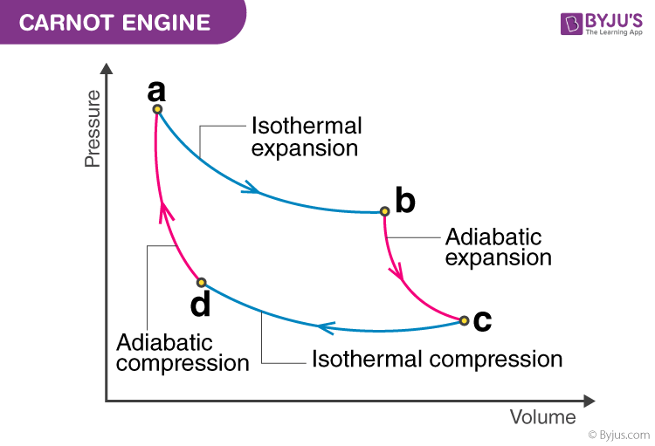

Carnot Theorem:
According to Carnot Theorem:
Any system working between two given temperatures T₁ (hot reservoir) and T₂ (cold reservoir), can never have an efficiency more than the Carnot engine working between the same reservoirs, respectively.
Also, the efficiency of this type of engine is independent of the nature of the working substance and is only dependent on the temperature of the hot and cold reservoirs.

Carnot Cycle:
A Carnot cycle is defined as an ideal reversible closed thermodynamic cycle in which there are four successive operations involved, which are isothermal expansion, adiabatic expansion, isothermal compression and adiabatic compression. During these operations, the expansion and compression of substance can be done up to the desired point and back to the initial state.
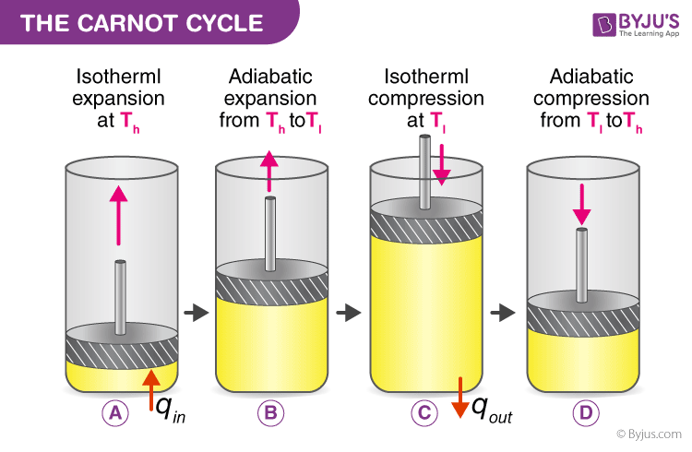
Following are the four processes of the Carnot cycle:
- In (a), the process is reversible isothermal gas expansion. In this process, the amount of heat absorbed by the ideal gas is q_{in} from the heat source, which is at a temperature of T_{h}. The gas expands and does work on the surroundings.
- In (b), the process is reversible adiabatic gas expansion. Here, the system is thermally insulated, and the gas continues to expand and work is done on the surroundings. Now the temperature is lower, T_{l}.
- In (c), the process is reversible isothermal gas compression process. Here, the heat loss q_{out} occurs when the surroundings do the work at temperature T_{l}.
- In (d), the process is reversible adiabatic gas compression. Again the system is thermally insulated. The temperature again rises back to T_{h} as the surrounding continue to do their work on the gas.

Steps involved in a Carnot Cycle
For an ideal gas operating inside a Carnot cycle, the following are the steps involved:

Step 1:
Isothermal expansion: The gas is taken from P₁, V₁, T₁ to P₂, V₂, T₂. Heat Q₁ is absorbed from the reservoir at temperature T₁. Since the expansion is isothermal, the total change in internal energy is zero, and the heat absorbed by the gas is equal to the work done by the gas on the environment, which is given as:
W1→2=Q1=μ×R×T1×lnv2v1

Step 2:
Adiabatic expansion: The gas expands adiabatically from P₂, V₂, T₁ to P₃, V₃, T₂.
Here, work done by the gas is given by:
W2→3=μRγ−1(T1−T2)

Step 3:
Isothermal compression: The gas is compressed isothermally from the state (P₃, V₃, T₂) to (P₄, V₄, T₂).
Here, the work done on the gas by the environment is given by:
W3→4=μRT2lnv3v4

Step 4:
Adiabatic compression: The gas is compressed adiabatically from the state (P₄, V₄, T₂) to (P₁, V₁, T₁).
Here, the work done on the gas by the environment is given by:
W4→1=μRγ−1(T1−T2)
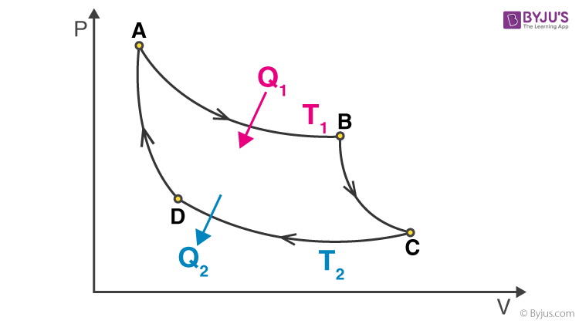
Hence, the total work done by the gas on the environment in one complete cycle is given by:
W=W1→2+W2→3+W3→4+W4→1W=μRT1lnv2v1−μRT2lnv3v4
Netefficiency=NetworkdonebythegasHeatabsorbedbythegas
Netefficiency=WQ1=Q1−Q2Q1=1−Q2Q1=1−T2T1lnv3v4lnv2v1
Since the step 2–>3 is an adiabatic process, we can write T₁V₂^{Ƴ-1} = T₂V₃^{Ƴ-1}
Or,
v2v3=(T2T1)1γ−1
Similarly, for the process 4–>1, we can write
v1v2=(T2T1)1γ−1
This implies,
v2v3=v1v2
So, the expression for net efficiency of carnot engine reduces to:
Netefficiency=1−T2T1

Frequently Asked Questions – FAQs

Q1. What is a working fluid in Carnot’s cycle?
The working fluid in a Carnot’s cycle is an ideal gas.

Q2. What is a Carnot heat engine?
Carnot heat engine is a theoretical engine that operates on a reversible carnot cycle. It has maximum efficiency that a heat engine can possess.

Q3. Name the processes involved in Carnot cycle?
It involves four process: isothermal expansion, adiabatic expansion, isothermal compression and adiabatic compression.

Q4. What happens in the isothermal expansion process?
In the isothermal expansion process, gas is taken from P1, V1, T1 to P2, V2, T2. Heat Q1 is absorbed from the reservoir at temperature T1. The total change in internal energy is zero and the heat absorbed by the gas is equal to the work done.

